Uniosun Journal of Agriculture and Renewable Resources, UJARR, Volume 6, Issue 1, June 2022.

Uniosun Journal of Agriculture and Renewable Resources

 UJARR

FULL LENGTH RESEARCH PAPER

Evaluating the effect of covid-19 pandemic on poultry production in Iwo Local Government of Osun State

**Aderemi, F.A.*, Alabi, O.M., Lawal, T.E., Ayoola,M.O., Oguntunji, A.O., Oladejo, O.A. and Akanji, G.**

*College of Agriculture, Engineering and Sciences, Bowen University Iwo Osun State Nigeria*

*\*Corresponding Author:* [foluke.aderemi@bowen.edu.ng](mailto:foluke.aderemi@bowen.edu.ng)

# A B S T R A C T

A striking appearance of new cases of viral pneumonia in Wuhan sometimes led to the detection of a novel coronavirus (SARS-CoV2). This created a new normal situation which necessitated this study. A well-structured questionnaire was used to gather data and later analysed using descriptive statistics in order to make inferences. A multistage sampling technique was used to select the poultry farmers while simple random technique was used to determine poultry farmers in Iwo Local Government. The result from the analysed data showed that all the poultry farmers in Iwo local government were affected in different ways. There were restrictions of movement, increase in price of feed and other inputs while sales volume of poultry products dropped drastically. This pandemic revealed that our current poultry production at various scales lack resilience or the capacity to adapt over the short term in the face of disturbance. In a bid to curtail the effect of pandemic in the nearest future government should play a decisive role in the production of poultry, starting from production of day old, supply of drugs and vaccines, promoting availability of feeds and feed ingredients, making funds or loans accessible to poultry farmers, encouraging farmers to join poultry association among other things. Government should establish new regulations for animal health care, trade, and movements of domestic and wild animals and provide adequate research funds for these activities to establish a strategic plan to ensure a continuous supply of animal protein in a bid to satisfy the consumers.

**Key words:** Poultry, consumers, pandemic, farmers

Evaluating the effect of covid-19 pandemic on poultry production in Iwo Local Government of Osun State

# INTRODUCTION

Covid-19 virus is an infectious disease caused by severe acute respiration syndrome corona virus. Symptoms include fever, cough and fatigue shortness of breath or sometimes loss of taste. The COVID-19 pandemic highlights that we exist in a global community. From a single city, it spread to 188 countries across the world and infected 30 million people by September 18, 2020. Decades of modelling pandemics predicted potential consequences, but COVID-19's impact on the food supply chain, and specifically livestock production was unexpected Marchant-Forde and Boyle (2020). In order to curb the spread of the

disease, various regional and national governments advocated for social distancing measures with varying degrees of enforcement, ranging from unenforced recommendations to quarantine and business closures. Physical activity is an important

determinant of health.

Pandemics are global outbreaks of infectious disease that can rapidly increase the rate of illness and mortality over a wide geographical area and cause high social, political and economic disturbance. It has been suggested due to the number of people that travel globally, unfairly use of natural resource and physical growth in urban areas there is probability of rapid increase pandemic over the years. (Morse, 1995, Jones *et al.*, 2008;). Pandemic may bring expected challenges but there are always unforeseen ramifications that transcends human health (Qiu et al 2017). After the swine flu pandemic, the World Health Organization conducted a review of its first line of defence—its International Health Regulations (2005)—and concluded that,

―The world is ill-prepared to respond to

a global, sustained and threatening public- health emergency.‖ (WHO 2005 and 2013 ). Various bodies including the WHO and US Centers for Disease Control and Prevention (CDC) have issued advice on preventing further spread of COVID-19 (WHO 2020 and Cagle 2020).

Livestock sector occupy about 30 per cent of the earth terrestrial surface area (Steinfeld *et al*., 2006) and are a significant global asset with a value of at least $1.4 trillion. The livestock sector in the developed world is increasingly organized in long market chains that employ at least 1.3 billion people globally and directly support the livelihoods of 600 million poor smallholder farmers in the developing world (Thornton *et al.*, 2006).

Poultry production is the raising of domestic birds like chicken, turkeys, ducks, and geese to produce foods (meat and eggs). The numbers of birds reared for eggs and meat has increased drastically in Middle East of china and Nigeria because of the high demand for eggs and meats (FAO, 2000).

In Nigeria almost 5% of daily energy is supply from animal products. 0.82% of the calories taken in on average is provided by poultry eggs and meat. In Nigeria livestock production, poultry occupies a special position as chicken eggs and meat increased with 20% from 2000 to 2007 with 5.4kg per capita in 2007.

Prior to the advent of Covid-19, Nigeria had already prohibited importation of poultry products to promote our productivity. The success of this action, implemented in October 2019, helped the country to raise its poultry population to an estimated 180 million, and an annual output in excess of 700,000 metric tonnes of eggs. This translates to about 450 million crates of eggs and 300,000 metric tonnes of meat (Agboola. 2020).

Uniosun Journal of Agriculture and Renewable Resources, UJARR, Volume 6, Issue 1, June 2022.

Government imposed lockdown to curb the spread of the virus however people considered to render essential services were exempted. The poultry Association made a special case for poultry workers. The aims of study are to consider the statistics of poultry production before and during the first wave of the pandemic with a view to proffer solutions to reduce economic impact on both producer and consumers in the future

.

# MATERIALS AND METHODS

**Study Area**

The study was carried out in Iwo city and her environs Iwo is one of the 30 Local Government Areas in Osun State; the town has an area of 245 km with a population 191,348 according to (National Population Commission, 2006). It is located between the coordinate axis of 7’38’N and 4’11’E. The latitude of Iwo, Osun State, Nigeria is 7.629209, and the longitude is 4.187218.

# Sampling and Data Collection

A multistage sampling technique was used to select the studied poultry farmers in Iwo local Government of Osun State. Then a simple random technique was used to determine poultry farmers in Iwo Local Government Area. Well-structured questionnaires were adopted in acquiring data from the respondents. The key information gathered includes the socio- economic information, farm related data, effect of Covid-19 pandemic on poultry production in Iwo local government, farmers’ awareness and response to covid-

19 pandemic. 100 questionnaires were randomly distributed among the poultry farmers in Iwo local Government, while 70 questionnaires that was completely filled and retrieved were analysed.

# Statistical Analysis.

Descriptive statistics was used for the analysis of data collected and represented by bar charts.

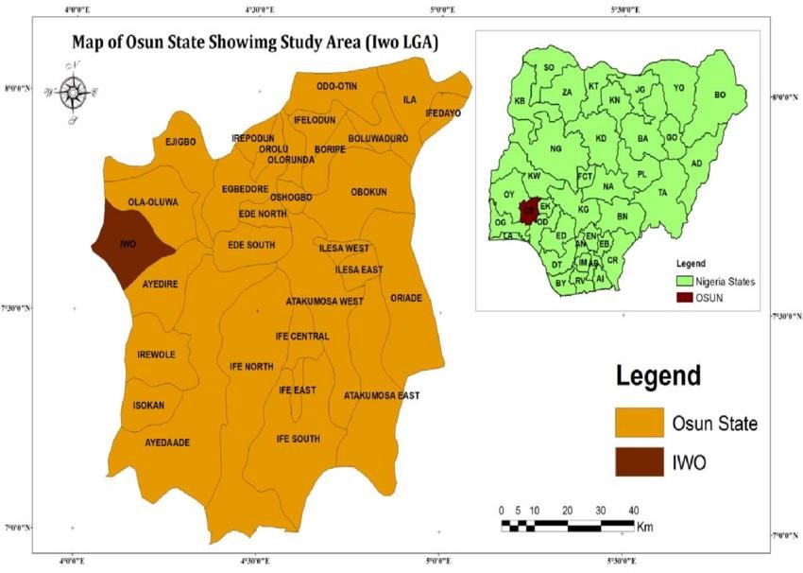

Figure.1. Map of Osun State showing the study area (Iwo Local Government) source: Research gate 2014.

# RESULTS AND DISCUSSION

The result in Figure 2 shows that 71.40% of males were involved in poultry

production while (28.6%) of female are involved in poultry production in the study. The result implied poultry production is male dominated. 18.60% of

Evaluating the effect of covid-19 pandemic on poultry production in Iwo Local Government of Osun State

respondents were between the ages of 31and 40, 31.4% were between the ages of 41 and 50 while 50% were 50years and above. It can be inferred that majority of poultry farmers were retirees. From our data most of these farmers are elderly and WHO advised elderly to stay indoor as they are vulnerable to the infection than younger people during the pandemic. There is need for paradigm shift this innovative business must be attractive to younger and energetic people. Majority (87.1%) of the poultry farmers in the study area were married, 10. 0 % were single while remaining 2.9% are widowed who has lost their spouses. This implies that in Iwo local government majority of poultry farmers were married, and by implication poultry production is carried out by responsible people in the society. Also (18.6%) had primary education, (41.4 %) had secondary education, and 37.1% had tertiary education while (2.9%) of poultry farmers in Iwo local government had informal education. The gap between secondary and tertiary is minimal to some extent this therefore reveals that majority of poultry farmers in Iwo local government are educated. This should reflect in higher productivity.

The distribution of the religious affiliation of respondents indicated that 47.1% were Christian, 51.4% were Muslims while 1.4% were traditional worshippers. This indicates that majority of poultry farmers in Iwo local government were Muslims by implication majority of Iwo people are Muslims.

Fig. 3 shows that 47.1% of the poultry farmers in Iwo local government have household of 1-5 people, 48.6% have a household of 6-10 people while 4.2% have household of people greater than 10. This implied the farmers had enough hands to help at the poultry farm. The figure

shows that 17.1% of poultry farmers in Iwo local government were members of poultry-related Associations while majority (82.9%) were not. By implication most of poultry farmers in this place do not belong to any poultry-related Association. Evidently from the bar chart, poultry farmers with 0-1years experience were 22.9%, 6-10years experience were 37.1%, 11-15years of poultry experience were 25.7%, while 15years above with poultry production were 14.3%. Most of the poultry farmers in the study area are well experienced. Also, 94.3% of respondents were operating sole ownership while 5.7% of respondents were operating partnership. The single ownership style will allow for decisions to be taken quickly. Finally 25.7% of the respondents depend on poultry farm as their main source of livelihood while 74.3% of respondents engaged in poultry business as ancillary occupation. Majority of the poultry farmers in this local government are

engaged in other business venture.

Before the pandemic, 24.3% of respondents produces 100-200 eggs daily, 44.3% produces 201-300 eggs daily,

15.7% produces 301-400 eggs daily,

10.0% produces 401-500 eggs daily while

5.7 produces more than 500 eggs daily. During the pandemic 60% of respondents produces 100-200 eggs daily, 30% produces 201-300 eggs daily, 4.3% produces 301-400 eggs daily while 5.7 produces 401-500 eggs daily. Evidently, Figure 4 shows that there is a decrease in daily egg production. Most farmers do not have free movement to their various farms and also due to the increased in price of feed most poultry farmers could not continue to feed their birds with enough quality feeds. Apparently, it resulted in reduced egg production.

Uniosun Journal of Agriculture and Renewable Resources, UJARR, Volume 6, Issue 1, June 2022.

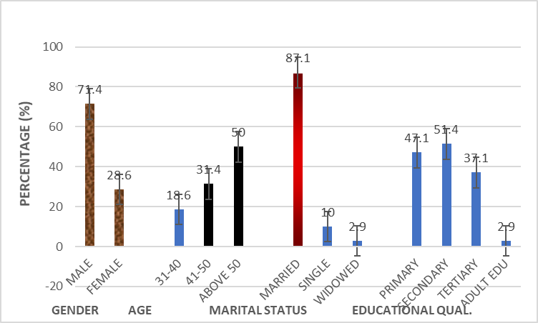

Fig. 2. Bar chart indicating the gender, age marital status and educational qualification of poultry farmers

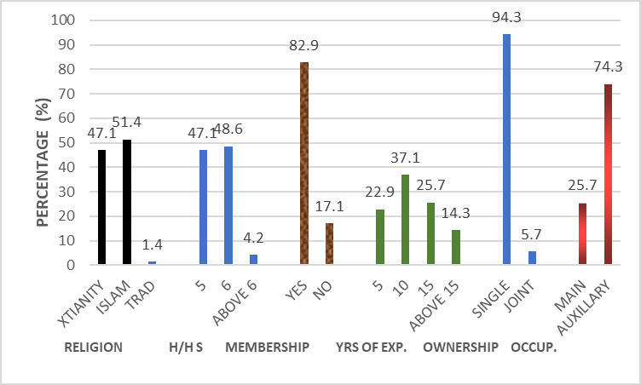

Fig. 3. Bar chart indicating the religion, household no, membership of association, years of experience ownership type and other occupation of poultry farmers

Poultry farmers sold egg before lock down as follows: 11.4% sold crate of egg between the prices of ₦500-₦600, 67.1% sold between ₦650-700, 5.7% sold between ₦750-₦800, 10.0% sold between

₦850-₦900 while 5.7% sold between the prices of ₦950- ₦1000. The figure above shows the prices of crate of egg during pandemic: 64.30% of respondents sold

crate of egg for ₦500 - ₦600, 28.6 % sold between ₦650 and ₦700, 7.1% sold between ₦750 and ₦800, this implies that due to the pandemic most poultry farmers were just disposing their crate of eggs at a reduced price implying lower profit accrued to the farmers

The 60.0% of respondents confirmed 25 kg bag of layer feed was sold

Evaluating the effect of covid-19 pandemic on poultry production in Iwo Local Government of Osun State

at price range between ₦3000 - ₦3400 before the pandemic while 40% said the price was between ₦3500 - ₦4000. According to the respondents 54.3% sold 25 kg bag of layer feed at the price range between ₦3000-₦3400 during the pandemic, 41.4% sold at ₦4000 - ₦4500 while 4.3% sold at the price of ₦5000. This reveals that during the pandemic there was an increase in the price of layer feed. This is as a result of restriction of movement, high transportation cost as well as law of demand and supply among other factors.

All (100%) respondents indicated increase in price of feed ingredients during Covid-19 pandemic. Maize (17.5%), fishmeal (12.9%), oyster shell (5.7%), soybeans (4.3%) and groundnut cake (1.4%). Maize contains high amount of energy that is required in every diet of poultry. This happened at the peak of having early maize, normally March and April is for early maize while late maize is between July and August. Maize production falls drastically during this period.

Antibiotic (44.3%), fowl pox (11.4%) (lasota 10%) (vitamins 10 %),

NCD (12.9%), Gumboro (8.6%) IIBVD

(2.9%) these drugs and vaccine were usually imported and since there was total

lockdown, these drugs were scarce. Veterinary doctors that are supposed to render services were also under lockdown.

82.9 % of poultry farmers in Iwo local government of Osun state did not enjoy free movement during the lockdown while just 17.1 % of the poultry farmers had little access to movement. Due to the restriction of interstate movement the study revealed that the pressing constraints faced by the poultry farmers includes increase in price of feed ingredient and finished feeds, decrease in demand for live chicken and eggs, culling out of laying birds during the pandemic was rampant which was at a loss to the farmers. Most farmers were operating at a reduced capacity during this period. This issue could be ameliorated if they belong to Poultry or related Association because the association made an appeal to government to consider their members as essentials workers and thereby ease their movement which was granted. The above scenario automatically resulted in high prices of feed as confirmed by the respondents. The 60.0% of respondents confirmed 25kg bag of layer feed was sold at price range between N3000-3400 before the pandemic while 40% said the price was between N3500-

4000.

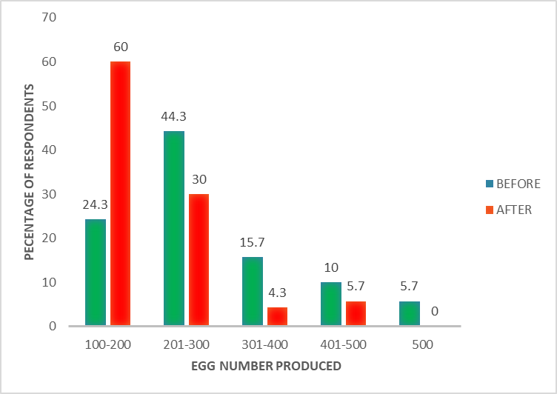

Fig 4. Bar chart indicating the pattern of egg production before and after wave1 pandemic

Uniosun Journal of Agriculture and Renewable Resources, UJARR, Volume 6, Issue 1, June 2022.

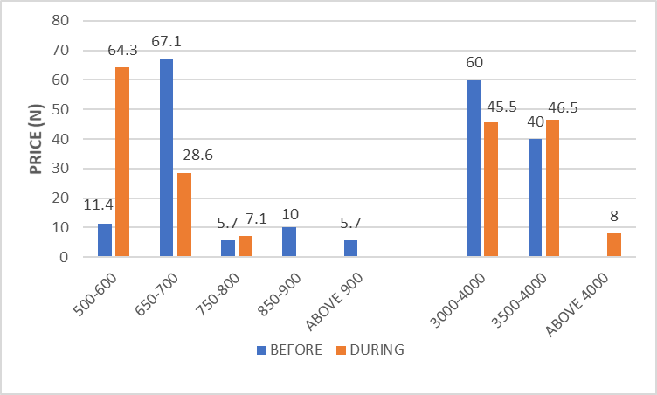

Fig. 5. Bar chart indicating the pattern of egg sales before and after wave1 pandemic

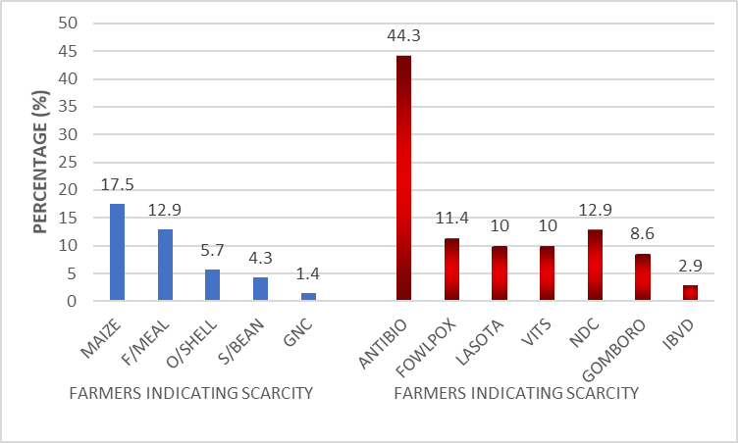

Fig. 6. Bar chart indicating scarcity of feed ingredients drugs and vaccines

According to the respondents 54.3% sold 25 kg bag of layer feed at the price range between ₦3000 - ₦3400 during the pandemic, 41.4% sold at ₦4000

- ₦4500 while 4.3% sold at higher price of

₦5000. This reveals that during the pandemic there was an increase in the price of poultry feed. This is as a result of restriction of movements; high transportation cost as well as law of demand and supply among other factors. The 74.3% of the farmers have other things doing. The 44.3% of farmers produce 200-300 eggs daily before the pandemic but during the lockdown, 30%

produces 200-300 eggs; daily decrease in production which could be due to restricted movement, so little or no access to feed and drugs. Accessing farm to render service was also hindered. Prices of drugs and vaccines went up in response to lockdown as most of these were imported so few drugs and vaccines that were available were purchased at high prices. Although we do not have a grave effect as it happened in the western world where large number of poultry were euthanized due to COVID-19, but there are reports of the culling of up to 10 million chickens in the U.S. (Kevany, 2020). Even at that

Evaluating the effect of covid-19 pandemic on poultry production in Iwo Local Government of Osun State

some farmers actually sold off their stock during the pandemic to avoid or reduce loss.

In most of our farms it is horizontal integration that is they are involved in only production of the birds, eggs and other products without feed mill and processing centre (Tendall *et al.*, 2015). By implication the farms will have to get feeds from other places probably feed mills this involve movement. Disposal of eggs was also associated with potential biosecurity risks and detrimental effects on the environmental welfare and highlighting the fragility of intensive high throughput livestock production systems. Pandemic resulted in increased feeding cost and raw ingredient prices as well as their availability which negatively influenced the growth of the industry and consumers’ purchasing power, particularly after the wave 1 COVID-19 pandemic. The immediate impact of COVID-19 was a wave of panic buying by the public in the western world but here in Iwo and Nigeria generally lack of funds did not permit the people to do any panic buying. In fact the well-meaning people resulted into distributing food stuffs eggs and other groceries as palliatives to people in churches and mosque to succour the hardship on people at this time. Both farmers and consumers alike had psychological stress during this period. Lockdown that restricted the farm attendants resulted in concentrated ammonia around the poultry. This is in agreement with Wilson and Serre (2007) who reported air around poultry sites contains hydrogen sulfide and ammonia, particulate matter, and bacteria. Such pollutants act as eye and respiratory irritants (Thorne, 2007). Unsurprisingly then, inhabitants are more likely to suffer more from asthma and other respiratory diseases Schultz *et al.* (2019). Exposure to this pollutant also contributes to mental

stress Horton *et al* (2009) and elevated blood pressure Wing *et al.* (2013).

In addition to promotion of wearing of nose masks, frequent hand washing and social distancing government could intervene to reduce price of feeds by buying major feed ingredients at the time of surplus and selling to farmers at subsidized rate in scarcity period. Government should make Agriculture especially poultry more attractive to young people by providing incentives for them.

# CONCLUSION

Animal farming around the world has become one, interconnected unit. Thus, the COVID-19 pandemic has highlighted the need for acknowledging the great risk that current viruses and future microorganisms that may lead to pandemics pose to animal health and human welfare. Governments should establish new regulations for animal health care, trade, and movements of domestic and wild animals and provide adequate research funds for these activities to establish a strategic plan to ensure a continuous supply of animal protein for consumers.

# Conflict of Interest

The authors declared there is no conflict of interest.

# REFERENCES

Agboola, J. (2020). Agricultural Economics & Extensionist, Value Chain Catalyst.

Cagle, S. A. (2020). Disastrous Situation: Mountains of Food Wasted as Coronavirus Scrambles Supply Chain. https:/[/www](http://www/). theguardian.com/world/2020/apr/09/us- coronavirus-outbreak-agriculturefood- supply-waste (accessed July 14, 2020).

Uniosun Journal of Agriculture and Renewable Resources, UJARR, Volume 6, Issue 1, June 2022.

FAO, (2000). Food and Agriculture Organization (FAO) publication

Horton, R.A., Wing S, Marshall, S.W., Brownley, K.A. (2009). Malodor as a trigger of stress and negative mood in neighbours of industrial hog operations. Am J Public Health. 99(Suppl. 3):S610–5 doi: 10.2105/AJPH.2008.148924

Jones, K E, Patel N G, Levy M A, Storeygard A, and Balk D. (2008). ―Global Trends in Emerging Infectious Diseases.‖ Nature 451 (7181): 990–93.

Kevany S. (2020). Millions of U.S. Farm Animals to be Culled by Suffocation, Drowning and Shooting. (2020). [https://www.theguardian.com/environment](https://www.theguardian.com/environment/2020/may/19/millions-of-us-farm-animals-to-be-culled-by-suffocation-drowning-and-shooting-coronavirus)

[/2020/may/19/millions-of-us-farm-](https://www.theguardian.com/environment/2020/may/19/millions-of-us-farm-animals-to-be-culled-by-suffocation-drowning-and-shooting-coronavirus) [animals-to-be-culled-by-suffocation-](https://www.theguardian.com/environment/2020/may/19/millions-of-us-farm-animals-to-be-culled-by-suffocation-drowning-and-shooting-coronavirus) [drowning-and-shooting-](https://www.theguardian.com/environment/2020/may/19/millions-of-us-farm-animals-to-be-culled-by-suffocation-drowning-and-shooting-coronavirus)

[coronavirus](https://www.theguardian.com/environment/2020/may/19/millions-of-us-farm-animals-to-be-culled-by-suffocation-drowning-and-shooting-coronavirus) (accessed July 15, 2020).

Marchant-Forde, J. N. and Boyle, L. A.(2020). Covid -19 effects on livestock production A one Welfare issue *Front,Vet Sci* 30 http//doi.org/10.3389/fvet2020.

585787

Morsel, S S. (1995). ―Factors in the Emergence of Infectious Diseases.‖ *Emerging Infectious Diseases*, 1 (1): 7–15.

National Population Commission (2006). Population and Housing Census Nigeria

Qiu, W, Rutherford, S., Mao, A., Chu, C. (2017). The pandemic and its impacts. *Health Cult Soc.* 9:1–11. doi: 10.5195/HCS.2017.221

Wing, S, Horton, R.A., Rose, K.M. (2013).. Air pollution from industrial swine operations and blood pressure of neighboring residents. *Environ Health Perspect*, 121:92–6

doi: 10.1289/ehp.1205109

WHO (World Health Organization). (2005). International Health Regulations. Geneva: Report of the Review Committee on the Functioning of the International Health Regulations in Relation to Pandemic (H1N1)

<http://apps.who.int/gb/ebwha/pdf_files/> WHA64/A64_10-en.pdf (accessed May 29, 2020)

WHO (World Health Organization). (2013). Global Survey on National Vaccine Deployment and Vaccination Plans for Pandemic A (H1N1) 2009 Vaccine—2010. Report of survey findings, WHO, Geneva

World Health Organization, Novel Coronavirus (2019-nCoV) (2020). Advice for the Public, https:/[/www.who.int/](http://www.who.int/emergencies/diseases)e[mergencies/diseases](http://www.who.int/emergencies/diseases)

/novel-coronavirus-2019/advice-for- public.

Wilson, S.M. and Serre, M.L. (2007). Examination of atmospheric ammonia levels near hog CAFOs, homes, and schools in eastern North Carolina. *Atmos Environ.* 41:4977–87.

doi: 10.1016/j.atmosenv.2006.12.055

Schultz, A.A., Peppard, P, Gangnon, R.E, Malecki, K.M. (2019). Residential proximity to concentrated animal feeding operations and allergic and respiratory disease. *Environ Int*. 130:104911. doi: 10.1016/j.envint.2019.1 04911

Steinfeld, H., Wassenaar, T. and Jutzi, S. (2006). Livestock production systems in developing countries: Status, drivers, trends. In World Organization for Animal Health (OIE) Scientific and Technical Review 25, 505–516.

Tendall D, Joerin J, Kopainsky B, Edwards P, Shreck A, Le QB, (2015). Food system resilience: defining the concept. *Glob Food Sec.* 6:17–23.

doi: 10.1016/j.gfs.2015.08.001

Evaluating the effect of covid-19 pandemic on poultry production in Iwo Local Government of Osun State

Notenbaert, A., Bekele, N. and Omolo, A.,

Thorne P. S. (2007) Environmental health impacts of concentrated animal feeding operations: anticipating hazards— searching for solutions. Environ Health Perspect. 115:296–7. doi: 10.1289/ehp.8831

Thornton, P.K., Jones, P.G., Owiyo, T., Kruska, R.L., Herrero, M., Kristjanson, P.,

with contributions from Orindi, V., Adwerah, A., Otiende, B., Bhadwal, S., Anantram, K., Nair, S. and Kumar, V. (2006). In Mapping climate vulnerability and poverty in Africa. Nairobi, International Livestock Research Institute. 159 pp.